AutoCare Database SQL Queries

Remove duplicate records and create a view of the clean data
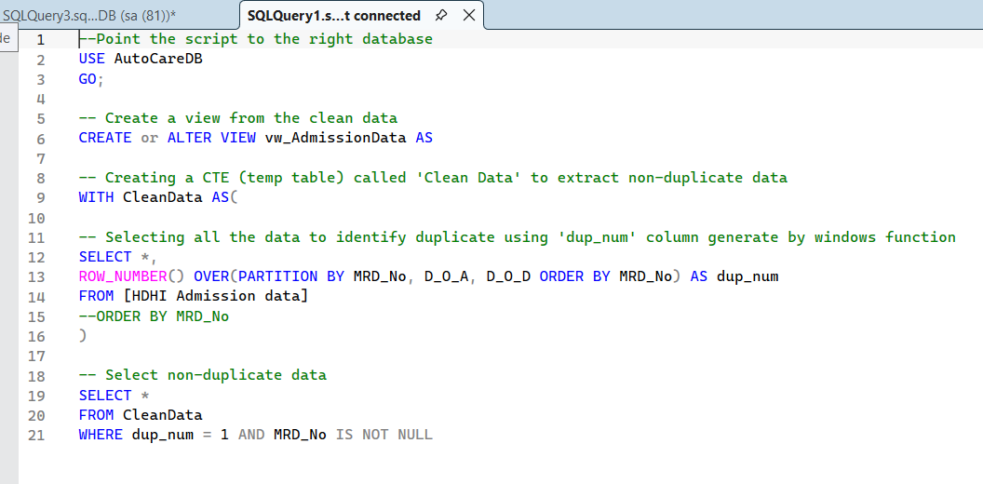

Problem #1: Identify the total number of discharges
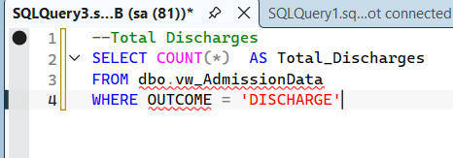
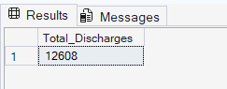

Problem #2: Identify Average Daily Discharge Rate




Problem #3: What is the average length of stay


Problem #4: What are the distributions of discharges by age group
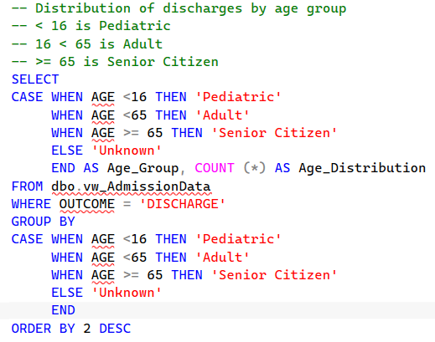
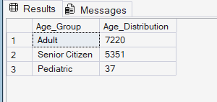
Problem #5: What are distributions of discharges by gender
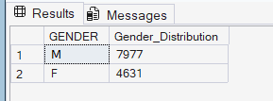

Problem #6: What are the distrubtions of discharges by day of the week
